8. Software Design Approach
The Student Record Management System was developed using the Waterfall Software Development Life Cycle (SDLC). This approach was chosen because the requirements of the project were already known before coding started. The Waterfall model allowed the team to follow a clear step-by-step process from planning to implementation.
The first stage was requirements analysis. During this stage, the team studied the project brief and identified the main functions that the system needed to perform. These included adding student records, searching for student information, updating records and controlling access according to different user roles. The system needed to support Administrators, Lecturers and Authorities each with specific responsibilities within the system.
The second stage was system design. Before coding started, the team created pseudocode and a UML class diagram to provide a clear understanding of how the system would operate. The UML diagram helped identify the major classes such as User, Student, Courses, Enrolment and DataStore and showed how these classes interact with one another.
The third stage was implementation. The design was converted into Java code using Object-Oriented Programming principles. Classes, constructors, methods, access modifiers and control structures were used to develop the required functionality. Java JFrame Forms were also used to create a user-friendly graphical interface.
The fourth stage was testing. Different functions such as login, student registration, student search, enrolment management and grade management were tested to ensure they worked correctly. Input validation and error handling were also checked to improve system reliability.
The final stage involved documenting the work completed and preparing the application for demonstration. The Waterfall approach helped the team complete the project in an organised and structured manner.

9. Engineering Method
The project followed a structured engineering method to solve the problem of managing student records manually. Manual record management can be slow and prone to mistakes. The purpose of the system was to provide a digital solution that makes student information easier to manage and access.
The first step was identifying the problem and understanding the project requirements. The team analysed the project brief and determined the features that the system needed to provide. These included user authentication, student record management, enrolment management and grade processing.
The second step was planning and design. The team developed pseudocode and UML diagrams before implementation. This made it easier to understand the structure of the system and reduced the chances of errors during coding.
The third step was system development. Java was used to develop the application and implement all the required features. The system was built using different classes, each responsible for performing a specific task. For example, the Student class stores student information while the DataStore class manages data and system operations.
The fourth step was testing and evaluation. The completed system was tested to ensure that users could log in successfully, manage student records and perform enrolment related functions correctly.
The final step was documentation. All stages of development were recorded in the technical report, together with the UML diagram and pseudocode. Following this engineering method helped the team develop a functional Student Record Management System that meets the project requirements.

10. Skills used
Several skills were required during the development of the Student Record Management System.
Programming skills were used throughout the project to develop the application using Java. Knowledge of Java programming helped the team implement user authentication, student management, enrolment management and grade management functions.
Object-Oriented Programming skills were also important. Concepts such as classes, objects, constructors, methods and access modifiers were used to organise the code into manageable sections. This made the system easier to develop and maintain.
Problem-solving skills were used when identifying errors, debugging code and implementing logical solutions to system requirements. These skills helped the team overcome challenges during development and testing.
Teamwork skills played an important role in the project. Responsibilities were divided among group members, with some members focusing on programming activities while others focused on report writing and documentation. Working together allowed the project to be completed more efficiently.
Communication skills were also necessary during project meetings and discussions. The team regularly shared ideas, discussed challenges and monitored project progress.
Technical writing skills were used to prepare the technical report, pseudocode and UML documentation required for submission.

11. Tools used
Several software tools were used during the design and development of the Student Record Management System.
Apache NetBeans IDE was used as the main development environment for writing, compiling, debugging and testing Java code. The IDE provided a convenient platform for implementing the software and identifying programming errors.
Java Development Kit (JDK) was used to compile and run the Java application. The JDK provided the libraries and tools required for Java software development.
Java JFrame Forms were used to create the graphical user interface of the application. The interface allowed users to perform actions such as logging in, managing student records and viewing information through a user friendly environment.
GitHub was used for version control and contribution management. Group members uploaded their work and tracked project progress using the repository. GitHub also helped maintain different versions of the project and supported collaboration among team members.
UML Modelling Tools were used to create the UML class diagram that assisted with system design and planning.
Microsoft Word was used to prepare, edit and format the technical report according to the project requirements.
These tools played an important role in improving productivity, collaboration and software quality throughout the project.

12. Pseudocode
The pseudocode was developed during the design stage to provide a clear description of the logical processes followed by the Student Record Management System before implementation. It served as a blueprint for coding by showing the sequence of operations and decision-making processes used within the system.
The pseudocode covers the major classes and functions of the system, including Course, Subject, User, Student, Enrolment and DataStore. It also describes important operations such as user authentication, student searches, module registration, grade updates and compliance auditing.
Algorithm 1: Student Record Management System Pseudocode

// ==========================================
// 1. COURSE CLASS PSEUDOCODE
// ==========================================
CLASS Course
PRIVATE PROPERTIES:
- code
- name

CONSTRUCTOR Course(code, name)
- SET this.code = code
- SET this.name = name
END CONSTRUCTOR

- FUNCTION getCode() RETURNS code END FUNCTION
- FUNCTION getName() RETURNS name END FUNCTION

END CLASS

// ========================================== //
2. SUBJECT CLASS PSEUDOCODE (Academic Module)
// ==========================================
CLASS Subject
PRIVATE PROPERTIES:
- code
- name
- courseCode
- lecturerUsername

CONSTRUCTOR Subject(code, name, courseCode, lecturerUsername)
- SET this.code = code
- SET this.name = name
- SET this.courseCode = courseCode
- SET this.lecturerUsername = lecturerUsername
END CONSTRUCTOR

- FUNCTION getCode() RETURNS code END FUNCTION
- FUNCTION getName() RETURNS name END FUNCTION
- FUNCTION getCourseCode() RETURNS courseCode END FUNCTION
- FUNCTION getLecturerUsername() RETURNS lecturerUsername END FUNCTION
END CLASS
// ==========================================
// 3. USER CLASS PSEUDOCODE (RBAC Model)
// ==========================================
CLASS User
PRIVATE PROPERTIES:
- username
- password
- role // LECTURER, ADMIN, AUTHORITY

CONSTRUCTOR User(username, password, role)
- SET this.username = username
- SET this.password = password
- SET this.role = role
END CONSTRUCTOR

- FUNCTION getUsername() RETURNS username END FUNCTION
- FUNCTION getRole() RETURNS role END FUNCTION
- FUNCTION checkPassword(input) RETURN password EQUALS input END FUNCTION
END CLASS
// ========================================== //
- STUDENT CLASS PSEUDOCODE //==========================================
CLASS Student
PRIVATE PROPERTIES:
- studentNumber
- firstName
- lastName
- email
- gender
- dob

CONSTRUCTOR Student(studentNumber, firstName, lastName, email, gender, dob)
- SET this.studentNumber = studentNumber
- SET this.firstName = firstName
- SET this.lastName = lastName
- SET this.email = email
- SET this.gender = gender
- SET this.dob = dob
END CONSTRUCTOR

- FUNCTION getStudentNumber() RETURNS studentNumber END FUNCTION
- FUNCTION getFirstName() RETURNS firstName END FUNCTION
- FUNCTION getLastName() RETURNS lastName END FUNCTION
- FUNCTION getEmail() RETURNS email END FUNCTION
- FUNCTION getGender() RETURNS gender END FUNCTION
- FUNCTION getDob() RETURNS dob END FUNCTION
END CLASS

// ==========================================
// 5. ENROLMENT CLASS PSEUDOCODE
// ==========================================
CLASS Enrolment
PRIVATE PROPERTIES:
- studentNumber
- moduleCode
- grade // -1 means not graded yet

CONSTRUCTOR Enrolment(studentNumber, moduleCode)
- SET this.studentNumber = studentNumber
- SET this.moduleCode = moduleCode
- SET this.grade = -1
END CONSTRUCTOR

- FUNCTION getStudentNumber() RETURNS studentNumber END FUNCTION
- FUNCTION getModuleCode() RETURNS moduleCode END FUNCTION

- FUNCTION getGrade() RETURNS grade END FUNCTION
- FUNCTION setGrade(newGrade) SET this.grade = newGrade END FUNCTION
END CLASS

// ==========================================
// 6. DATA STORE / CONTROLLER CLASS PSEUDOCODE
// ==========================================
CLASS DataStore
STATIC LISTS:
- users = ArrayList of User
- students = ArrayList of Student
- courses = ArrayList of Course
- subjects = ArrayList of Subject
- enrolments = ArrayList of Enrolment

// --- Authentication ---
FUNCTION login(username, password)
IF username == NULL OR password == NULL THEN RETURN NULL END IF
SET supplied = username.trim()
FOR EACH user IN users
IF user.getUsername() EQUALS_IGNORE_CASE supplied AND user.checkPassword(password) THEN
RETURN user
END IF
END FOR
RETURN NULL
END FUNCTION

// --- Searches & Lookups ---
FUNCTION findStudent(studentNumber)
- SET key = clean(studentNumber)
- IF key.isEmpty() THEN RETURN NULL END IF
- FOR EACH student IN students
IF student.getStudentNumber() EQUALS_IGNORE_CASE key THEN
RETURN student
END IF
END FOR
RETURN NULL
END FUNCTION

FUNCTION searchStudents(keyword)
- SET result = Empty List of Student
- SET search = clean(keyword).toLowerCase()
- FOR EACH student IN students
IF student.getStudentNumber().toLowerCase().contains(search)
OR student.getFirstName().toLowerCase().contains(search)
OR student.getLastName().toLowerCase().contains(search)
OR student.getEmail().toLowerCase().contains(search) THEN
ADD student TO result
END IF
END FOR
RETURN result
END FUNCTION

FUNCTION findModule(subjectCode)
- SET key = clean(subjectCode)
- FOR EACH subject IN subjects
IF subject.getCode() EQUALS_IGNORE_CASE key THEN
RETURN subject
END IF
END FOR
RETURN NULL
END FUNCTION

FUNCTION modulesForLecturer(username)
- SET result = Empty List of Subject
- SET key = clean(username)
- FOR EACH subject IN subjects
IF subject.getLecturerUsername().equalsIgnoreCase(key) THEN
ADD subject TO result
END IF
END FOR
RETURN result
END FUNCTION

// --- Registration & Data Validation ---
FUNCTION register(studentNumber, moduleCode)
- SET studentNumber = clean(studentNumber)
- SET moduleCode = clean(moduleCode).toUpperCase()

IF NOT studentNumber.matches("\\d{9}") THEN RETURN "Student number must contain exactly 9 digits." END IF
IF findStudent(studentNumber) == NULL THEN RETURN "Student not found." END IF
IF findModule(moduleCode) == NULL THEN RETURN "Module not found." END IF
IF findEnrolment(studentNumber, moduleCode) != NULL THEN RETURN "Student is already registered for this module." END IF

ADD NEW Enrolment(studentNumber, moduleCode) TO enrolments
RETURN NULL
END FUNCTION

FUNCTION updateGrade(studentNumber, moduleCode, grade)
- IF grade < 0 OR grade > 100 THEN RETURN "Grade must be a number between 0 and 100." END IF
- SET enrolment = findEnrolment(studentNumber, moduleCode)
- IF enrolment == NULL THEN RETURN "The student is not registered for this module." END IF

CALL enrolment.setGrade(grade)
RETURN NULL
END FUNCTION

// --- Compliance Auditing ---
FUNCTION performAudit(studentNumber)
- SET student = findStudent(studentNumber)
- IF student == NULL THEN RETURN NULL END IF

SET enrolled = 0
SET ungraded = 0
FOR EACH e IN enrolments
IF e.getStudentNumber() EQUALS student.getStudentNumber() THEN
enrolled++
IF NOT hasGrade(e.getStudentNumber(), e.getModuleCode()) THEN ungraded++ END IF
END IF
END FOR

SET issues = Empty List of String
IF enrolled == 0 THEN ADD "not registered in any module" TO issues END IF
IF ungraded > 0 THEN ADD ungraded + " grade(s) pending" TO issues END IF
IF student.getEmail() == NULL OR NOT student.getEmail().contains("@") THEN ADD "invalid email" TO issues END IF

IF issues.isEmpty() THEN RETURN "In compliance"
ELSE RETURN "Not in compliance: " + JOIN(issues, "; ")
END FUNCTION

END CLASS

The pseudocode helped the team understand how the system should operate before development started. It also ensured that the final implementation followed the planned logic and met the requirements specified in the project brief.

13. UML Diagram
The UML Class Diagram was developed during the design phase to provide a visual representation of the structure of the Student Record Management System. The diagram illustrates the relationships between users, students, courses, enrolments and the central data management component.
The diagram shows how different classes interact to perform system operations. The User class is responsible for authentication and access control, while the Student class stores student information. The Courses and Enrolment classes manage academic information and student registrations. The DataStore class acts as the central component that manages system data and operations. The dashboard classes provide interfaces for different user roles such as Administrators, Lecturers and Authorities.
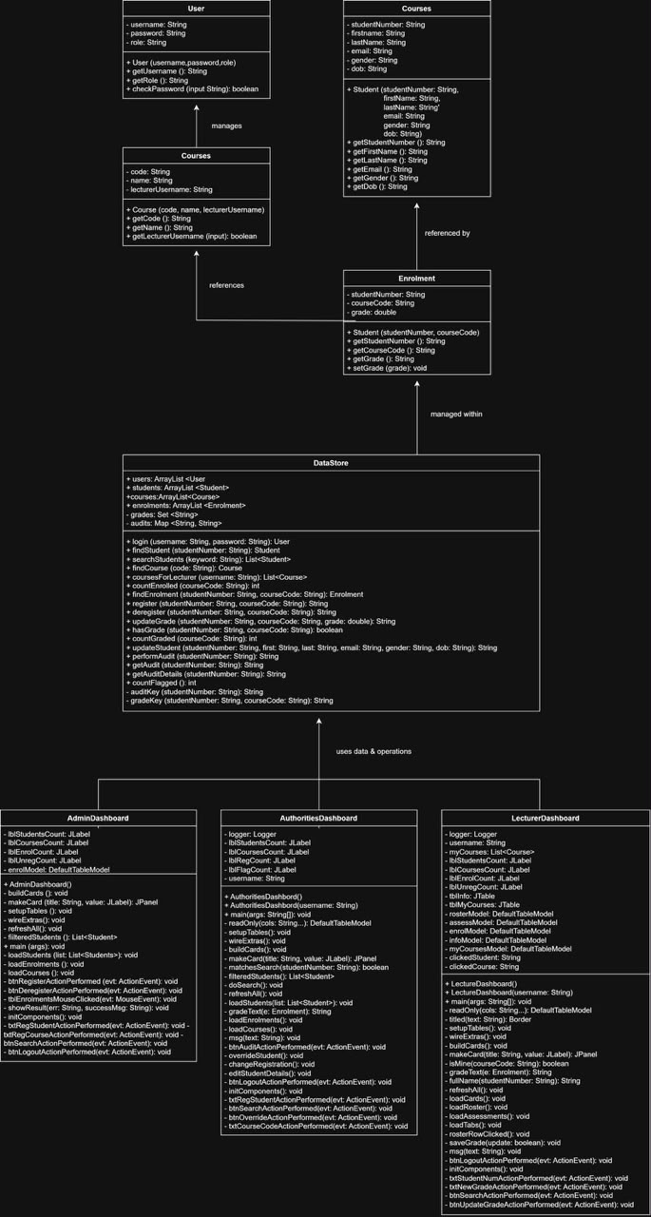

The UML diagram helped the team visualise the overall structure of the application before implementation. It also demonstrates the use of Object-Oriented Programming principles and shows how responsibilities are distributed among different classes. This improved code organisation, maintainability and system design.

